
Department of Electrical and Computer Engineering
North South University

Senior Design Project

Unveiling PII in Pre-trained Models: Investigating Data Accountability in LLMs

Adnan Bakth Mazmader | 2031727642
Md. Abul Bashar Nirob | 2022198042

Faculty Advisor:
Dr. Mohammad Ashrafuzzaman Khan
Associate Professor
ECE Department

Summer, 2024

LETTER OF TRANSMITTAL
12 December, 2024
To
Prof. Mohammad A Matin
Chairman,
Department of Electrical and Computer Engineering
North South University, Dhaka
Subject: Submission of Capstone Project Report on “Unveiling PII in Pre-trained Models: Investigating Data Accountability in LLMs”
Dear Sir,
With due respect, we would like to submit our Capstone Project Report on “Write your CSE/EEE499 Capstone Project Title/Name HERE” as a part of our BSc program. The report deals with Multi Level Based Home Security System. This project was very much valuable to us as it helped us gain experience from practical field and apply in real life. We tried to the maximum competence to meet all the dimensions required from this report.
We will be highly obliged if you kindly receive this report and provide your valuable judgment. It would be our immense pleasure if you find this report useful and informative to have an apparent perspective on the issue.
Sincerely Yours,

.........................................................
Student Name1
ECE Department
North South University, Bangladesh

........................................................
Student Name2
ECE Department
North South University, Bangladesh

APPROVAL
Adnan Bakth Mazmader (2031727642), and Md. Abul Bashar Nirob (2022198042) from Electrical and Computer Engineering Department of North South University, have worked on the Senior Design Project titled “Unveiling PII in Pre-trained Models: Investigating Data Accountability in LLMs” under the supervision of Dr. Mohammad Ashrafuzzaman Khan partial fulfillment of the requirement for the degree of Bachelors of Science in Engineering and has been accepted as satisfactory.

Supervisor’s Signature

…………………………………….
Dr. Mohammad Ashrafuzzaman Khan
Associate Professor
Department of Electrical and Computer Engineering
North South University
Dhaka, Bangladesh.

Chairman’s Signature

…………………………………….
Prof. Mohammad A Matin
Professor
Department of Electrical and Computer Engineering
North South University
Dhaka, Bangladesh.

DECLARATION
This is to declare that this project is our original work. No part of this work has been submitted elsewhere partially or fully for the award of any other degree or diploma. All project related information will remain confidential and shall not be disclosed without the formal consent of the project supervisor. Relevant previous works presented in this report have been properly acknowledged and cited. The plagiarism policy, as stated by the supervisor, has been maintained.

Students’ names & Signatures

1. Adnan Bakth Mazmader

_ _ _ _ _ _ _ _ _ _ _ _ _ _ _ _ _
2. Md. Abul Bashar Nirob

_ _ _ _ _ _ _ _ _ _ _ _ _ _ _ _ _

ACKNOWLEDGEMENTS
The authors would like to express their heartfelt gratitude towards their project and research supervisor, Dr. Mohammad Ashrafuzzaman Khan, Associate Professor, Department of Electrical and Computer Engineering, North South University, Bangladesh, for his invaluable support, precise guidance and advice pertaining to the experiments, research and theoretical studies carried out during the course of the current project and also in the preparation of the current report.
Furthermore, the authors would like to thank the Department of Electrical and Computer Engineering, North South University, Bangladesh for facilitating the research. We would also like to thank my friend Md Rokon Hossain for helping us in this project. The authors would also like to thank their loved ones for their countless sacrifices and continual support.

ABSTRACT
Unveiling PII in Pre-trained Models: Investigating Data Accountability in LLMs
The rapid gain in popularity for Artificial Intelligence can be credited towards Large Language Models like GPT, BERT, and many others. They have revolutionized natural language processing by enabling robust text generation capabilities. However, these advancements come with significant challenges. LLMs are often trained with huge datasets scraped off the web. This results in them being exposed to sensitive data such as personally identifiable information (PII). Our research investigates methodologies to detect the presence of PII in LLM pre-training datasets, contributing to greater data accountability. We evaluated multiple techniques, including Min-K%, Min-K%++, and proposed our novel Token Probability and Frequency Scoring (TPFS) method, across various LLMs. TPFS demonstrates robust performance by using external token frequency distributions for more reliable detection of memorized PII. After demonstrating the risks of privacy leakage via LLMs, we introduce a negative sampling-based machine unlearning approach to mitigate privacy risks. The results reveal that detecting and unlearning sensitive data is feasible, and if done on a greater scale can lay the groundwork for enhancing ethical AI practices and compliance with data protection regulations like GDPR.
TABLE OF CONTENTS
LETTER OF TRANSMITTAL 2
APPROVAL 3
DECLARATION 4
ACKNOWLEDGEMENTS 5
ABSTRACT 6
LIST OF FIGURES 9
LIST OF TABLES 10
Chapter 1 Introduction 11
1.1 Background and Motivation 11
1.2 Purpose and Goal of the Project 11
1.3 Organization of the Report 11
Chapter 2 Research Literature Review 13
2.1 Existing Research and Limitations 13
Chapter 3 Methodology 15
3.1 System Design 15
3.2 Software Components 20
3.3 Hardware and/or Software Implementation 22
Chapter 4 Investigation/Experiment, Result, Analysis and Discussion 24
Chapter 5 Impacts of the Project 28
5.1 Impact of this project on societal, health, safety, legal and cultural issues 28
5.2 Impact of this project on environment and sustainability 29
Chapter 6 Project Planning and Budget 31
Chapter 7 Complex Engineering Problems and Activities 32
7.1 Complex Engineering Problems (CEP) 32
7.2 Complex Engineering Activities (CEA) 33
Chapter 8 Conclusions 34
8.1 Summary 34
8.2 Limitations 34
8.3 Future Improvement 35
References 37

LIST OF FIGURES
Figure 1: TPFS workflow 17
Figure 2: OPT 2.7B ROC Curve 24
Figure 3: GPT-NEO 2.7B 25
Figure 4: Result of Unlearning 27
Figure 5: Project Timeline 31

LIST OF TABLES
Table 1: Sample data 21
Table 2: software tools 22
Table 3:Results 26
Table 4: Complex Engineering problem attributes 32
Table 5: Complex Engineering Problem Activities (CEA) 33

Chapter 1 Introduction

Background and Motivation
The advancement of Machine Learning (ML) and Natural Language Processing (NLP) has led to the creation of powerful generative models, such as GPT-2 and GPT-Neo. These models are trained on vast datasets collected from publicly available sources, often containing diverse information from across the internet. However, a major concern is that the publicly available datasets are not often well filtered, thus using them without any filtration for model training could lead to inclusion of Personally Identifiable Information (PII). PII can include sensitive data such as names, address, phone numbers, and other details that can be used to identify individuals. Which leads to violation of General Data Protection Regulation (GDPR) enacted by European Union in 2018. Such practice can lead to unintended privacy breaches.

Purpose and Goal of the Project
Through our project we aimed to develop a novel methodology to detect PII within pre-trained Large Language Model (LLMs). Our primary goal is to identify whether specific PII has been incorporated into the training datasets of LLMs. By detecting PIIs from various models, we can enhance the integrity of the LLMs to be built in near future.

Organization of the Report
Introduction: Discussion about the Background and Motivation, and goal of the project
Research Literature Review: Discussion on what related works have been done on this domain, and the limitations
Methodology: Discussion on the Novel approach that we have followed to detect PII in LLMs
Investigation/Experiment, Result, Analysis and Discussion: Discussion on our results and findings
Impact of the Project: Discussion on the impact of our project in the LLM projects
Project planning and budget: Overview of project planning and budget
Conclusion: An overview of the whole project, along with brief discussion for further improvement in future

Chapter 2 Research Literature Review

2.1 Existing Research and Limitations
Data is one of the most important factors for the success of Large Language models (LLMs). As training corpus grows in scale, it has increasing tendency to be held in-house as proprietary data instead of being publicly disclosed. However, for large-scale training corpora that consist of consequences. For example, memorized private information is vulnerable to data extraction. Till present, very few researches have been done to develop strategies for pre-training data detection.
Membership inference attack. Membership inference attack (MIA) was first proposed by Shokri et al [1]. MIA has been extensively studied, particularly in classification models within the computer vision domain [2]. While there is growing attention to MIA in language models, most work has focused on detecting fine-tuning data [3]. MIA can serve as a powerful tool for detecting copyrighted materials [4].
Detecting Pre-training Data in LLMs. Although detecting pre-training data is an instance of MIA, it faces greater challenges compared to traditional MIA. Classical MIA [1] typically requires training a shadow model using data sampled from the training data distribution. However, for large language models, many developers are reluctant to release the full training data [5], making it impractical to train shadow models. Additionally, due to the sheer volume of training data, LLMs are usually trained for a single epoch, which makes memorization inherently difficult and detection even more challenging [2].
To our knowledge, Shi et al [6] was the first to investigate this problem, contributing a baseline method and the WikiMIA benchmark. Their method, Min-K%, despite its simplicity, serves as a powerful baseline. Zhang et al [7] enhanced Min-K% by normalizing token log-probabilities. The ReCall method [8] introduces relative conditional log-likelihoods and achieves current state-of-the-art performance
Contrastive Decoding. Contrastive decoding is primarily a method for text generation. Depending on the elements being contrasted, it serves different purposes. For example, DExperts [9] use outputs from a model exposed to toxicity to guide the target model away from undesirable outputs. Context-aware decoding [6] contrasts model outputs given a query with and without relevant context. Zhao et al [10] further enhance context-aware decoding by providing irrelevant context in addition to relevant context. In this paper, we adapt the idea of contrastive decoding to MIA, where the contrast occurs between target data prefixed with member and non-member contexts.

Chapter 3 Methodology

3.1 System Design
The main objective of our project is to detect the presence of personally identifiable information (PII) such as full names in LLMs’ pre-training data. To achieve this, we used three different approaches. MIN-K%, MIN-K%++ and Token probability and Frequency Scoring (TPFS) have been used, out of which TPFs is our own proposed method for a better understanding of the existence of PII in the training of LLMs. This section describes all the methods explored, with all necessary equations and theoretical foundations.
MIN-K%: Identifying Least Probable Tokens
The MIN-K% method focuses on log probability scores of tokens given by pre-trained models. After calculating log probabilities for all tokens in a sequence, they are sorted in ascending order and the lowest K% of them is selected. The mean of those K% of the scores is the MIN-K% score. Since a more negative log-probability means higher confidence, taking the lowest k% of tokens means selecting the tokens model that recognizes the most.
Token Probabilities:
For a sequence S = {t₁, t₂, …, t_{n}}, when t_{i} represents the i-th token, the language model computes the probability P(t_{i}) for each token:
$$P\left(t_{i}\right)=softmax{\left(z\right)}_{i}= \frac{e^{zi}}{\sum_{j=1}^{V}{e^{zj}}}$$
Where z is the logits vector for token t_{i}, and V is the vocabulary size.
Sorting and Selecting the Bottom k% tokens:
Sort the token probabilities {P(t₁), P(t₂), …, P(t_{n})} in ascending order:
$$P_{sorted}=\left\{P_{1}, P_{2}, …, P_{n}\right\}, where P_{1} ≤P_{2} ≤… ≤P_{n}$$
Select the smallest k% of the token probabilities:
$$K=max⁡(1,⌊k.n / 100⌋)$$
Where K is the number of tokens in the bottom K%.
Min-K% Score:
The score is computed as the mean of the smallest k% token probabilities:
$$MIN-K\% \left(S\right)=\frac{1}{k} \sum_{i=1}^{K}{P_{i}}$$
MIN-K++: Normalized Least Probable Tokens
The MIN-K%++ method builds upon MIN-K% by normalizing token probabilities to account for variations in sequence length and probability distributions. This is achieved by transforming token probabilities into z-scores based on the mean and standard deviation of the probabilities within the sequence. The smallest k% normalized scores are then averaged to compute the MIN-K++ score, offering a more robust metric.
Normalization of Token Probabilities:
Compute the mean µ and standard deviation σ of token probabilities for the sequence:
$$µ=\frac{1}{n} \sum_{i=1}^{n}{P\left(t_{i}\right), σ=\sqrt{\frac{1}{n} \sum_{i=1}^{n}{{\left(P_{t_{i}}-µ\right)}^{2}} }}$$
Normalize each token probability:
$$P_{normalized}= \frac{P\left(t_{i}\right)- µ}{σ}$$
Sorting and selecting the Bottom K% Normalized Scores:
Similar to MIN-K%, sort the normalized probabilities and select the bottom k%:
$$P_{normalized},_{ sorted}=\{P_{1}^{normalized}, P_{2}^{normalized}, …, P_{n}^{normalized}\}$$
MIN-K++ Score:
Compute the average of the smallest K% normalized probabilities:
$$MIN-K++\left(S\right)=\frac{1}{K} \sum_{i=1}^{K}{P_{i}^{normalized}}$$
TPFS (Token probability and Frequency Scoring)
The Token Probability and Frequency Scoring (TPFS) method works by combining the token probabilities output by a pre-trained language model (e.g., GPT-2, OPT) with token frequency distributions derived from an external reference corpus. This method identifies cases where the model assigns disproportionately high probabilities to specific tokens relative to their frequency in general language usage.
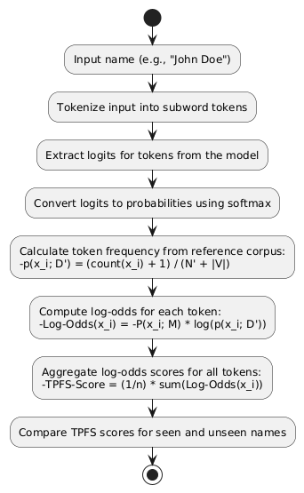
Figure 1: TPFS workflow

Steps in TPFS
Logit Extraction and Probability Calculation:
The model processes the input tokens and outputs logits for all tokens in the vocabulary. These logits are converted into probabilities using the SoftMax function:
$$P\left(y=i | x\right)= \frac{e^{logit_{i}}}{\sum_{j}{e^{logit_{j}}}}$$
Here,
- P (y = i|x): Probability of the i-th token given the input x
- logit_{i}: Logit value for the i-th token
The probabilities for the tokens in the input sequence are stored for further computation.
Token Frequency Distribution from Reference Corpus:
For each token x_{i} in the input, its frequency is computed using a reference corpus:
$$p\left(x_{i}, D^{'}\right)= \frac{count\left(x_{i}\right)+1}{N^{'}+ |V|}$$
Where,
- count(x_{i}): Number of times the token x_{i} appears in the reference corpus
- N': Total number of tokens in the reference corpus
- |V|: Vocabulary size of the tokenizer
- +1: Laplace smoothing to avoid zero probabilities for unseen tokens
Log-Odds Calculation:
For each token x_{i}, the log-odds is computed to compare the model’s confidence with its general frequency in the reference corpus:
$$Log-Odds\left(x_{i}\right)= -P\left(x_{i};M\right).log⁡(p\left(x_{i},:D^{'}\right))$$
Here,
- P (x_{i}; M): Probability of the token x_{i} predicted by the model
- P (x_{i}; D'): Frequency of the token x_{i} in the reference corpus.
Score Aggregation:
The log-odds scores for all tokens in the name are aggregated to compute a final TPFS score for the entire sequence:
$$TPFS-Score=\frac{1}{n} \sum_{i=1}^{n}{Log-Odds(x_{i})}$$
Where n is the number of tokens in the sequence.
Comparison of Scores:
The TPFS scores for seen and unseen names are compared to analyze the model’s behavior. Names with higher TPFS scores are more likely to have been memorized by the model.
Token Probability and Frequency Scoring (TPFS) effectively accounts for names that are frequently found in general language by leveraging token frequencies derived from a reference corpus. For high-frequency names like "John Smith," the token frequency in the reference corpus will be relatively high. This reduces the impact of the log-odds calculation, as the logarithmic term becomes smaller for frequent tokens. Consequently, the final TPFS score for such names is moderated, even if the model assigns them high probabilities. This ensures that TPFS does not mistakenly flag common names as memorized, as their high probabilities are consistent with their general usage in the language. By considering both model probabilities and external frequency data, TPFS distinguishes between memorization and natural language predictions for high-frequency names, ensuring robustness in detecting genuinely memorized PII.
Unlearning:
After we were successfully able to detect the use of PII pre-training for LLMs, we decided to propose a method to resolve the issue. The fact that LLMs have seen PII during training means there is huge risk of privacy leakage. Machine Unlearning can be the key to mitigating such risks.
There are various ways this problem could be approached, but to show that our method works, we did this on a smaller scale using the GPT-2 Medium model. The dataset that we used is the Enron email dataset. Using regex we extracted the email addresses to act as our seen data and synthetic emails of the same pattern were generated to be used as unseen data.
Before unlearning, MIN-K% was applied to see a model's ability to recognize seen data so that it can be compared after unlearning.

Now, coming to the unlearning process, we applied negative sampling. That involves fine-tuning the model to overwrite its associations with sensitive data. This is done by replacing sensitive text with a generic placeholder like email@example.com. The model is set to training mode, and an optimizer (AdamW) is used to update the model parameters. During training, each piece of sensitive text is paired with the corresponding placeholder, and both are tokenized to create input and label sequences. The model minimizes the loss between its predictions and the placeholder text. Over ten epochs, the model learns to predict the placeholder instead of the original sensitive content, thereby unlearning its prior association. Average loss is monitored at each epoch to track progress, ensuring the model gradually replaces the specific patterns of sensitive data with generic, non-identifiable content. Lastly, MIN-K% was applied after unlearning and results before and after unlearning were compared.

3.2 Software Components
A wide variety of software components have been used for the sake of this project. In order to distinguish between the models’ ability to recognize information based on whether it has seen it or not, we had to check for their performance on different datasets. In total, three different datasets were used, seen dataset, unseen dataset, and the reference dataset.
The seen dataset was a collection of real full names extracted from OpenWebText using Named Entity Recognition (NER). This is because most of the models we have tested on have either been trained directly on OpenWebText or subsets of it. And to distinguish the models’ performance between the seen and unseen data, the unseen data was synthetic full names generated with help of the Faker library, which represented data the model has never seen. Lastly, for TPFS, a reference corpus was required, real full names were extracted from WikiMIA-24 dataset using NER. This allowed us to calculate token frequency distributions. For the processing of all this data, Spacy was used to implement NER techniques for extraction of names. For each experiment 500 samples of both seen and unseen names were used. Additionally, for the token frequency distribution, 12000 names were extracted as reference names.
Example of data used:

Table 1: Sample data
SEEN NAMES | UNSEEN NAMES | REFERENCE NAMES
David Wain | Rebeca Gomes | Brittany Payne
Judith Permar | Isabela Martins | Nikol Pashinyan
Gianvito Rossi | Benjamim Peixoto | Nicolas Gilsoul
Noam Chomsky | Eduarda Rios | Brooke Jenkins
John O’Neil | Sofia Ferreira | Sunil Narine
Alec Taylor | Daniel Jesus | Ebrahim Raisi
Steve Eder | Nicole Cavalcanti | Minami Takahashi
Laura Lark | Lucas Cirino | jack Markell
Cory Emmerton | Mariah Souza | Volodymyr Dvornikov
peter Eisler | Valentim Guerra | Ethan Page
For model evaluation, several pre-trained language models are used: GPT-2 Medium, OPT 2.7B, Pythia 1.4B, etc. These models were selected to provide a range of parameter sizes and architectures, ensuring a comprehensive comparison of methodologies like TPFS, Min-K%, and Min-K%++. The Hugging Face Transformers library is used for loading and running these models. Other essential software tools include Matplotlib for visualizing ROC curves and score distributions, and PyTorch for handling deep learning computations. The Hugging Face Datasets library provides easy access to datasets like OpenWebText and WikiMIA, enabling smooth integration into the workflow. These tools were chosen for their reliability, ease of use, and compatibility with the project’s requirements. WikiMIA, enabling smooth integration into the workflow. These tools were chosen for their reliability, ease of use, and compatibility with the project’s requirements.

Table 2: software tools
Tool | Functions | Other Similar Tools | Why selected
Transformers | Tokenization, inference for LLMs | Fairseq | Easy to use, wide model compatibility
SpaCy | NER for extracting names | Stanza, Flair | Reliable and lightweight for name extraction
Faker | Synthetic name generation | None | Versatile and locale-specific name generation
Matplotlib | Visualization of ROC curves and distributions | Seaborn, Plotly | Simple and customizable plotting
Hugging Face Datasets | Access to datasets like OpenWebText and WikiMIA | TensorFlow Datasets | Preprocessed datasets for NLP tasks
PyTorch | Deep learning framework for running models | TensorFlow | Supports Hugging Face models effectively

3.3 Hardware and/or Software Implementation
The implementation of this project is structured into four main stages. First, the datasets were prepared by extracting names from OpenWebText using SpaCy’s NER capabilities to form the seen dataset. Synthetic names were generated using the Faker library, ensuring diverse and unseen data for testing, while WikiMIA datasets were used to compute token frequency distributions for TPFS.
Second, token probabilities were extracted from the selected pre-trained language models, such as GPT-2 Medium and OPT 2.7B, using Hugging Face’s Transformers library. The models were used to process names and output logits for all tokens in their vocabularies, which were subsequently converted to probabilities using SoftMax.
Third, the methodologies were implemented. For Min-K%, the minimum probability among the top-K token probabilities was calculated, while for Min-K%++, the normalized probability of the top-K tokens was determined. TPFS was implemented by calculating log-odds scores for each token, comparing the model’s predicted probabilities with token frequencies derived from the reference corpus, and aggregating these scores to compute a single TPFS score for each name.
Finally, the results were evaluated by comparing the scores from all three methods across the seen and unseen datasets. ROC curves were plotted, and AUC values were calculated to assess the separability of scores, providing insights into the effectiveness of each methodology in detecting memorization. This pipeline ensures a robust and repeatable analysis of model behavior with respect to PII detection.

Chapter 4 Investigation/Experiment, Result, Analysis and Discussion
The results for our project are visualized through Receiver Operating Characteristic (ROC) curves which show how well the model is able to distinguish between seen and unseen data. The y-axis is the True positive rate and the x-axis is the False positive rate. Each plot has three curves, one each for TPFS, MIN-K% and MIN-K%++. The closer the curve is to the top left corner, the better the performance. To get a better grasp of the results, Area Under the Curve (AUC) was also calculated. The higher the AUC value the better the method for detecting PII in pre-training data. We have run experiments on several LLMs, such as OPT 2.7B, GPT-NEO 2.7B as well as many other models.
K = 20% | K = 80% | K = 100%
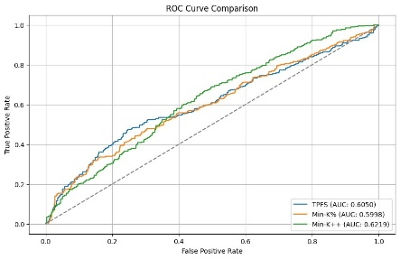 | 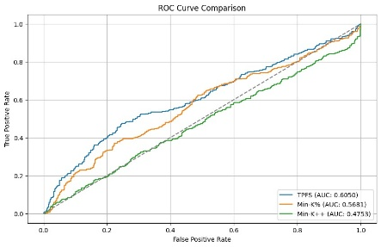 | 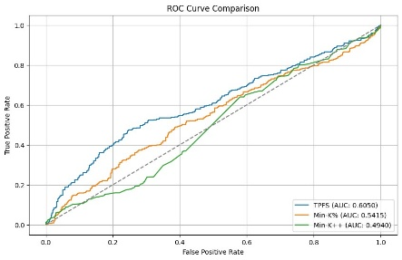
Figure 2: OPT 2.7B ROC Curve
Here, we have the results for the OPT 2.7B variant. We can see that when only K = 20% of the tokens are taken for MIN-K% and MIN-K%++ methods, the AUC is very similar. For MIN-K%++, it is the highest at 0.6219, second highest for TPFS at 0.6050 and lowest for MIN-K% at 0.5998. Even though results here are similar, we can tell TPFS works better than the other methods because MIN-K% and MIN-K%++ only consider the 20% of tokens with the highest scores. This means any token that may be part of general language could be flagged as memorized even though it is very common. For example, in the name ‘casey’, sub-word tokenization leads to the formation of the token ‘case’ which is part of general language. So, tokens like that will be part of the 20% and hence, results for MIN-K% and MIN-K%++ are biased. On the other hand, TPFS considers all the tokens in its scoring which gives us a better idea of how well the model distinguishes between seen and unseen data. TPFS solves this issue as
This is even more evident if we look at the results for K = 80% and 100%. Since higher percentages of tokens are used for scoring in MIN-K% and MIN-K%++, their AUC score decreases. For K = 100%, the AUC score had decreased to 0.5415 and 0.4940 for MIN-K% and MIN-K%++ respectively which is lower than TPFS. This shows that while selecting lower percentages of tokens for the mean score might be effective when detecting pre-training data as a whole, for smaller sequence lengths this is not as effective. Even for longer text lengths tokens such as ‘the’ and ‘a’ are selected to be in the top-K and thus results are biased. TPFS solves this issue as it scores all tokens in a sequence and aggregates their score. Also, for common tokens, their frequency score will be high and so will be the probability score, so log-odds score is adjusted so that common tokens are flagged to be not memorized.
K = 20% | K = 80 | K = 100
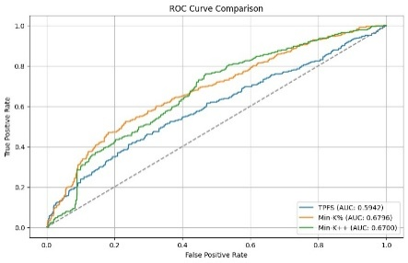 | 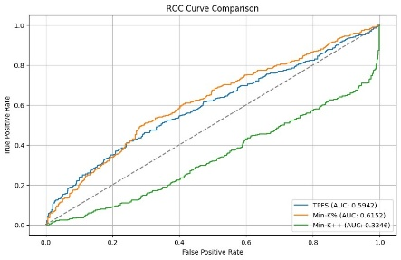 | 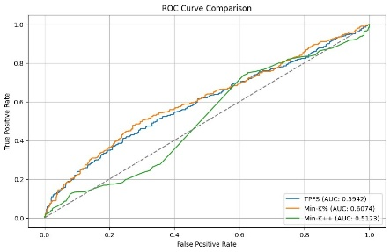
Figure 3: GPT-NEO 2.7B
results for TPFS are slightly worse than MIN-K% and MIN-K%++. TPFS had an AUC of 0.5942 whereas MIN-K% and MIN-K%++ had 0.6796 and 0.6700 respectively. But, as soon as the value for K is increased, there is a shift in the performance. The AUC for MIN-K%++ diminished quite a lot whereas for MIN-K%, it decreased to a similar level as TPFS. When K = 100%, MIN-K% and MIN-K%++ have an AUC of 0.6074 and 0.5123 respectively. So, in the case of this model, we can see the same issue with MIN-K% and MIN-K%++ where the scores are biased due to top-K tokens being part of regular language.
Table 3:Results
MODEL | TPFS | mink% (0.2) | mink% (0.8) | mink% (1) | mink++(0.2) | mink++(0.8) | mink++(1)
GPT-2XL | 0.5509 | 0.6510 | 0.5688 | 0.5714 | 0.6952 | 0.3058 | 0.5155
GPT-2 MED | 0.5132 | 0.5929 | 0.5049 | 0.5155 | 0.6643 | 0.3335 | 0.5337
GPT-NEO 1.3B | 0.5820 | 0.6475 | 0.5990 | 0.6006 | 0.6525 | 0.3290 | 0.4937
GPT-NEO 2.7B | 0.5942 | 0.6796 | 0.6152 | 0.6074 | 0.6700 | 0.3346 | 0.5123
OPT 1.3B | 0.5369 | 0.6487 | 0.5708 | 0.5753 | 0.6593 | 0.4911 | 0.3301
OPT 2.7B | 0.6050 | 0.5998 | 0.5681 | 0.5415 | 0.6219 | 0.4753 | 0.4940
Pythia 1.4B | 0.5842 | 0.6495 | 0.5996 | 0.6006 | 0.6339 | 0.3621 | 0.5277
Pythia 2.4B | 0.5608 | 0.6078 | 0.5742 | 0.5791 | 0.6139 | 0.3967 | 0.5109
The Area Under the Curve (AUC) for TPFS is generally observed to be slightly lower than that of Min-K% and Min-K%++. This is because TPFS incorporates token frequency information from an external reference corpus, which naturally reduces the sensitivity to overconfidence in predictions for high-frequency names that are common in general language. By moderating scores for such names, TPFS trades off some sensitivity for robustness, resulting in a slightly lower AUC in cases where high-frequency names are prominent.
In general Min-K%, when K = 20% does the best out of all the methods. When the value for K increases, there is always a noticeable decrease in AUC. For Min-K% across all models, K = 80% and K = 100% does not make much of a difference. But, the case with Min-K%++ is totally different. In most cases when K value is increased the performance declines, but when K is increased from 80% to 100%, there is a significant increase in performance. For example, in the case of GPT-XL, Min-K%++ had a score of 0.6952 when K = 20%, the score dropped drastically when K was increased to 80% which is much more than expected. The issue is when K is increased to 100%, the AUC increases by a lot, but it is still lower than when K is 20%. This is because Min-K%++ is based on z-score. As a result, when K is increased from 20 to 80, z-score drops as more low probability tokens are included in the final score. But when K is increased to 100, the variability in the token probabilities is reduced, resulting in a more stable z-score and a higher AUC.
For Min-K% and Min-K%++, as the value of K is increased, their scores tend to decrease and align more closely with TPFS scores. This occurs because higher values of K dilute the effect of outlier tokens with extreme probabilities, making the methods less sensitive to model overconfidence for specific tokens. This behavior mimics TPFS’s broader strategy of balancing token probabilities with external frequency distributions, thereby reducing the gap in performance between the methods at higher K.
In summary, TPFS achieves a more consistent balance by design, which explains its slightly lower AUC compared to Min-K% and Min-K++ at smaller K. However, as K increases for the other methods, they converge to similar performance levels, further validating TPFS as a robust alternative.
Moreover, as our reference corpus was not big enough, this affected TPFS as it uses the reference dataset to calculate token frequency distribution. The small size of the reference corpus underestimates token frequencies, which inflates log-odds scores for tokens, especially rare ones. This makes TPFS less effective at separating seen from unseen data compared to methods like Min-K% and Min-K++, which do not rely on external token frequency data. Therefore, having a larger reference corpus will definitely lead to better results from TPFS.
These results show the risk of privacy leakage through LLMs. As we discussed earlier, we proposed a method for mitigating such risks through negative sampling. The experiment was run on GPT-2 Medium, and MIN-K% was applied.
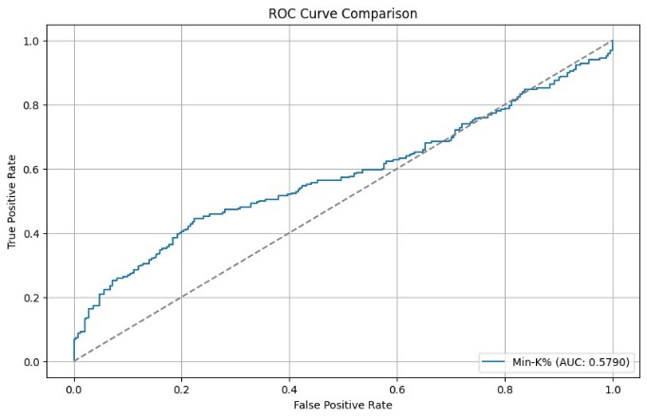 | 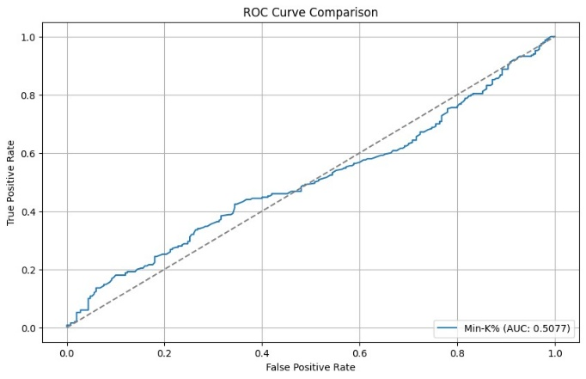
Before Unlearning | After Unlearning
Figure 4: Result of Unlearning
Before unlearning, we got an AUC score of 0.5790 which shows that model has some level of recognition towards seen data which are enron email addresses. After unlearning the score dropped to 0.5077. Even though the difference is not much, we can still say that unlearning was achieved to some extent. The results could be better if the number of epochs during unlearning was increased. But, even with only 10 epochs we were able to show that unlearning to a degree is possible. 0.5077 AUC means the model has almost no ability to distinguish between seen and unseen data. That means its association with the sensitive seen data has been minimized.

Chapter 5 Impacts of the Project

5.1 Impact of this project on societal, health, safety, legal and cultural issues
The detection of Personally Identifiable Information (PII) memorization in pre-trained large language models (LLMs) has profound implications for society, law, and culture. This project addresses critical concerns about privacy and data protection, aligning closely with global regulations such as the General Data Protection Regulation (GDPR) and the California Consumer Privacy Act (CCPA). By exploring whether LLMs memorize PII, the project contributes to building trust in AI systems by highlighting potential privacy risks and encouraging the development of safer, more ethical AI technologies.
Societal Impact
The growing reliance on LLMs in various applications, from customer support to medical advice, raises concerns about the unintended exposure of sensitive personal information. This project directly contributes to societal well-being by identifying and addressing such risks, ultimately fostering public trust in AI systems. Furthermore, by advocating for responsible AI development, the project supports broader societal goals of ensuring AI systems respect individual rights and privacy.
Legal Impact
The findings from this project could influence the legal landscape surrounding AI and data usage. Demonstrating how PII memorization occurs in LLMs provides actionable insights to regulators and policymakers for enforcing data protection laws like GDPR. By emphasizing the importance of auditing pre-trained models for privacy risks, this research could help shape future regulatory guidelines for AI model training and deployment, ensuring compliance with legal frameworks.
Cultural Impact
Culturally, this project promotes awareness of the ethical challenges posed by AI systems. It emphasizes the need for inclusivity and fairness by ensuring that AI models do not inadvertently expose sensitive data. Additionally, the project encourages a cultural shift toward transparency and accountability in AI development, fostering a more informed public dialogue on the ethical implications of AI technologies.

5.2 Impact of this project on environment and sustainability
The identification of personal data in pretraining data utilized by Large Language Models (LLMs) brings up significant sustainability issues that involve social and environmental effects. This addresses these sustainability concerns while demonstrating the viability of such detection.
Environmental Sustainability
Energy Consumption
Energy usage may result from computationally demanding procedures used to detect private information from LLM databases. It's critical to optimize algorithms for efficiency and process data in an energy-efficient manner, even with constrained resources. This can include doing analyses on more manageable, representative datasets in order to lower the total computational burden while maintaining the project's goals.
Efficient Resource Utilization
Using energy-efficient hardware and optimizing code to prevent unnecessary computations are two ways to lessen environmental impact. The project's sustainability plan may also include choosing cloud computing resources that are powered by renewable energy sources, if such resources are available. A reduced carbon footprint is achieved during the detection phase by emphasizing effective coding techniques and minimizing the utilization of resources.
Social Sustainability
Data Privacy and Protection
The project's main goal is to identify and draw attention to private information that promotes social sustainability by addressing important privacy concerns in AI. The experiment emphasizes the significance of ethical data handling procedures by proving that it is possible to discover sensitive data in pretraining datasets. Ensuring sufficient detection of private information contributes to the creation of responsible AI systems that uphold the privacy of individuals.
Raising Awareness of Ethical AI Practices
The necessity of ethical issues in AI research is also emphasized by this project. Through presenting techniques for identifying personal data, it increases awareness regarding the significance of transparency and fairness in artificial intelligence systems. This promotes a responsible data handling culture, which is necessary to increase public trust in AI systems.

Chapter 6 Project Planning and Budget
Project planning:
Figure 5: Project Timeline

Budget:
The project was completed without any cost as all experiments were run using online notebooks like Kaggle and Google Colab.

Chapter 7 Complex Engineering Problems and Activities

7.1 Complex Engineering Problems (CEP)
Table 4: Complex Engineering problem attributes
Attributes |  | Addressing the complex engineering problems (P) in the project
P1 | Depth of knowledge required (K3-K8) | The project demanded expertise in machine learning, natural language processing, statistical analysis, and software engineering tools like Hugging Face Transformers and PyTorch.
P2 | Range of conflicting requirements | Balancing detection accuracy with computational efficiency required significant trade-offs in model design and methodology selection.
P3 | Depth of analysis required | The project involved analyzing multiple LLMs and datasets to develop a robust understanding of PII detection and unlearning methodologies.
P4 | Familiarity of issues | The project addressed emerging challenges in AI ethics and data privacy, necessitating a deep understanding of LLM architectures and privacy risks.
P5 | Extent of applicable codes | The research adhered to ethical guidelines and data protection regulations such as GDPR, emphasizing compliance in AI development.
P6 | Extent of stakeholder involvement | The project involved collaboration with academia and potential implications for policymakers and AI developers.
P7 | Interdependence | Multiple interdependent components, including tokenization, probability calculations, and unlearning processes, were integrated into a cohesive framework.

7.2 Complex Engineering Activities (CEA)

Table 5: Complex Engineering Problem Activities (CEA)
Attributes |  | Addressing the complex engineering activities (A) in the project
A1 | Range of resources | Utilized cloud-based platforms like Kaggle and Google Colab, along with open-source tools for NLP and deep learning.
A2 | Level of interactions | Required collaboration among team members and engagement with diverse tools and datasets.
A3 | Innovation | Introduced the novel TPFS methodology, combining token probabilities with external frequency data to detect PII.
A4 | Consequences to society  / Environment | Addressed critical societal concerns by enhancing the privacy and ethical accountability of AI systems.
A5 | Familiarity | Required familiarity with AI frameworks, privacy laws, and statistical methodologies, contributing to UN SDG goals related to responsible AI.

Chapter 8 Conclusions

8.1 Summary
In this research, we have investigated existing methodologies for detecting the presence of Personally Identifiable Information (PII) in pre-training datasets of Large Language Models (LLMs), considering their limitations we have built a robust alternative. By addressing privacy concerns, our work contributes to enhancing data accountability and promoting ethical AI practices. We evaluated three key techniques: Min-K%, Min-K%++, and our novel Token Probability and Frequency Scoring (TPFS) method, across various LLMs, including OPT-2.7B, GPT-Neo-2.7B, and GPT-XL.
The results revealed that TPFS is a robust alternative to existing methods. Although Min-K% demonstrated the highest Area Under the Curve (AUC) when K = 20%, its performance declined significantly as K increased, converging closer to TPFS scores. TPFS’s advantage lies in its ability to evaluate all tokens while incorporating external token frequency distributions, which mitigates bias towards frequent general language tokens. This ensures a more balanced and consistent detection of PII. Despite its slightly lower AUC compared to Min-K% at smaller K values, TPFS provides superior performance, particularly as K increases or when token probabilities are diluted.
Additionally, we highlighted the risks of privacy leakage in LLMs and introduced a negative sampling-based machine unlearning approach to mitigate these risks. Initial experiments demonstrated the feasibility of this method, showcasing its potential to enhance compliance with data protection regulations such as GDPR.

8.2 Limitations
While the proposed TPFS method shows promise, certain limitations were identified during our research:
Dependence on Reference Corpus: TPFS relies on external token frequency distributions from a reference corpus. The small size of the reference dataset led to an underestimation of token frequencies, which affected the accuracy of log-odds scores, particularly for rare tokens. A larger and more comprehensive reference corpus would improve TPFS performance.
Performance Trade-offs: TPFS prioritizes robustness over sensitivity. While it moderates overconfidence in high-frequency tokens, this trade-off can result in slightly lower AUC values compared to Min-K% and Min-K++ at lower K values.
Evaluation on Limited Models: Although multiple LLMs were evaluated, the scope of experiments was limited to a subset of models. Performance results might vary for larger or differently trained LLMs.
Scalability of Mitigation Methods: The negative sampling-based machine unlearning approach demonstrated feasibility on a smaller scale but requires further validation on larger LLMs with extensive datasets to confirm its scalability and efficiency.

8.3 Future Improvement
To address the identified limitations and expand upon this research, the following future improvements are proposed:
Enhancing Reference Corpus: Increasing the size and diversity of the external reference corpus will significantly improve the accuracy of TPFS by providing more reliable token frequency distributions. This will reduce the inflation of log-odds scores for rare tokens and improve detection performance.
Scalability of Mitigation Techniques: Expanding the negative sampling-based machine unlearning method to larger models like GPT-3 or GPT-4 and testing it on extensive datasets will ensure its practicality for real-world applications.
Generalization to Different Privacy Risks: While this work focused on PII detection, similar approaches could be applied to other types of sensitive data, such as financial or medical information. Extending the methodology to these domains will make the framework more comprehensive.
Automated Data Filtration Pipelines: Developing automated pipelines for identifying and mitigating sensitive data during LLM pre-training will enable proactive compliance with data protection regulations like GDPR. Such tools can integrate detection (TPFS, Min-K%) with mitigation (negative sampling) in a scalable manner.
Broader Evaluation: Future work should include a broader range of models and datasets to validate the generalizability of TPFS and unlearning techniques across different architectures and pre-training strategies.
By addressing these areas, this research can pave the way for more ethical and accountable AI systems, reducing the risks of privacy breaches and aligning LLM training processes with global data protection standards.

References

[1] | R. Shokri, P. Liu and S. Zarifzadeh, "Low-Cost High-Power Membership Inference Attacks," Forty-first International Conference on Machine Learning, 2024.
[2] | N. Carlini, J. Hayes, M. Nasr, M. Jagielski, V. Sehwag, F. Tramer, B. Balle, D. Ippolito and E. Wallace, "Extracting training data from diffusion models," 32nd USENIX Security Symposium (USENIX Security 23), pp. 5253-5270, 2023.
[3] | M. Bertran, S. Tang, M. Kearns, J. Morgenstern, A. Roth and Z. S. Wu, "Scalable membership inference attacks via quantile regression," Advances in Neural Information Processing Systems, vol. 36, 2024.
[4] | M. Meeus, J. Shubham, M. Rei and Y.-A. d. Montjoye, "Did the neurons read your book? document-level membership inference for large language models," 33rd USENIX Security Symposium (USENIX Security 24), pp. 2369-2385, 2024.
[5] | H. Touvron, T. Lavril, G. Izacard, X. Martinet, M.-A. Lachaux, T. Lacroix, B. Roziere, N. Goyal, E. Hambro, F. Azhar, A. Rodriguez, A. Joulin, E. Grave and G. Lample, "Llama: Open and efficient foundation language models," arXiv preprint arXiv:2302.13971, 2023.
[6] | W. Shi, A. Ajith, M. Xia, Y. Huang, D. Liu, T. Blevins, D. Chen and L. Zettlemoyer, "Detecting Pretraining Data from Large Language Models," The Twelfth International Conference on Learning Representations, 2024.
[7] | J. Zhang, J. Sun, E. Yeats, Y. Ouyang, M. Kuo, J. Zhang, H. F. Yang and H. Li , "Min-k\%++: Improved baseline for detecting pre-training data from large language models," arXiv preprint arXiv:2404.02936, 2024.
[8] | R. Xie, J. Wang, R. Huang, M. Zhang, R. Ge, J. Pei, N. Z. Gong and B. Dhingra, "Recall: Membership inference via relative conditional log-likelihoods," arXiv preprint arXiv:2406.15968, 2024.
[9] | A. Liu, M. Sap, X. Lu, S. Swayamdipta, C. Bhagavatula, N. A. Smith and Y. Choi, "DExperts: Decoding-Time Controlled Text Generation with Experts and Anti-Experts," Association for Computational Linguistics, pp. 6691-6706, 2021.
[10] | Z. Zhao, E. Monti, J. Lehmann and H. Assem, "Enhancing Contextual Understanding in Large Language Models through Contrastive Decoding," Association for Computational Linguistics, pp. 4225-4237, 2024.

